Development Asia – Explainer

An explainer talks about a concept and/or a technical term relevant to development challenges, using plain language to discuss ideas and perspectives on the topic. Materials in a wide range of formats (e.g., videos, infographics) may be used to explain the underlying logic and perspectives that a concept and/or a technical term is trying to crystalize and convey to policymakers around the world and peers in development communities.

View sample explainers on the website. For more information, contact ​info@development.asia.

- Basic Information

1.1. Expert’s bio
Expert  (Up to 50 words for each bio) | Please provide a brief bio of the expert(s) associated with the content. The institution that holds the copyright of the original content may be listed along with the expert. Please provide a brief introduction of the institution.  Please include a link to the expert's LinkedIn page if available. Other social media links and contact information are welcome.  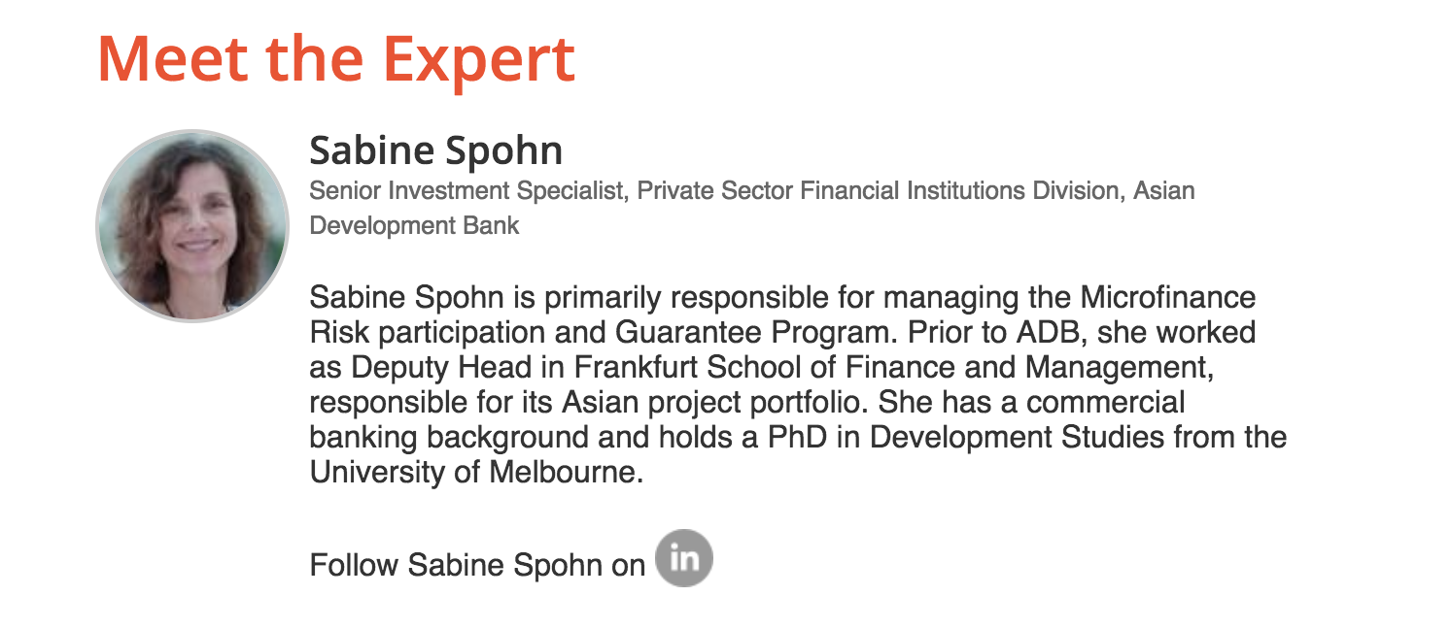

1.2. Check box for sectors
Sector | Which sector does this article primarily address? You may select more than one but not more than three sectors.

 | Agriculture and natural resources |  | Health
 | Capacity development |  | Industry and trade
 | Civil society |  | Information and communications technology
 | Climate change |  | Poverty
 | Economics |  | Private sector development
 | Education |  | Regional cooperation and integration
 | Energy |  | Social development and protection
 | Environment |  | Transport
 | Finance sector development |  | Urban development
 | Gender |  | Water
 | Governance and public sector management

1.3. Check box for SDGs
SDGs | Choose which Sustainable Development Goal (SDGs) is most relevant to this article. Select up to 3 SDGs only.

 | Goal 1: No Poverty |  | Goal 10: Reduced Inequalities
 | Goal 2: Zero Hunger |  | Goal 11: Sustainable Cities and Communities
 | Goal 3: Good Health and Well-being |  | Goal 12: Responsible Consumption and Production
 | Goal 4: Quality Education |  | Goal 13: Climate Action
 | Goal 5: Gender Equality |  | Goal 14: Life Below Water
 | Goal 6: Clean Water and Sanitation |  | Goal 15: Life on Land
 | Goal 7: Affordable and Clean Energy |  | Goal 16: Peace, Justice and Strong Institutions
 | Goal 8: Decent Work and Economic Growth |  | Goal 17: Partnerships for the Goals
 | Goal 9: Industry, Innovation and Infrastructure

1.4. Keywords
Keywords | Add 5–10 keywords or phrases, including the topic and country/region (if applicable) to be included in the metadata.

1.5. List of attachments
Photos and other materials | - Portrait photo of expert(s) and/or high-resolution logo of institution (see 1.1).  - Please provide a photo that is most relevant to the content with a brief caption that tells the location and context of the photo. If you are submitting a copyrighted photo, please ask the copyright owner to sign the attached consent form.  - Photo caption:  - Context:  - Date:  - Location:  - You may submit additional materials that can support the content, such as annexes, infographics, videos, before-and-after photos, design plans, and other materials.

- Content

2.1. Definition in a box
Definition  (100 words) | Please define the concept and/or technical term. Use analogies or examples to illustrate its meaning.

2.2. Main text (may include video/infographic)
Main text  (800 words) | Explainers create “a scaffold of understanding” that provides context for understanding a concept and/or a technical term used by experts in the development community.  You may use a Q&A format, short videos, and infographics to illustrate the logic and perspectives behind the concept/technical term with simple and easy-to-understand descriptions.  For some examples, check out How Markets Can Help Us Adapt to Climate Change from the New York Times or What’s the Deal With Algorithms? from Slate magazine. The Asian Development Bank produces explainer videos (for example, ADB's Project Cycle) on a variety of topics, as well as explainer infographics on the drivers of change that underpin much of its work.

2.3. Resources
Resources | Please provide a list of references, including the original report if applicable, and/or recommended content (journal articles, publications, YouTube videos, etc.) that are relevant to the concept and/or the technical term you are explaining.  For books, use the following model for format and punctuation.  Author. Year. Title in Italics. City: Publisher.  Author. Year. Title in Italics. City: Publisher. page number.  For periodicals, use the following model for format and punctuation.  Author. Year. Title of Article. Journal or Newspaper Title in Italics. Volume  number (issue number).  Author. Year. Title of Article. Journal or Newspaper Title in Italics. Volume  number (issue number). page number.  Please provide links for resources that are available online.

2.4. Blurb
Short one-sentence blurb  (150 characters, including spaces) | Write a short, relevant summary to inform and interest users. This one-sentence blurb will be displayed on the homepage and search results page of not only the Development Asia website but also search engines, such as Google.  A good blurb that contains relevant keywords will help researchers on the internet find your article.  Our editors can help you optimize your one-sentence blurbs for search engines.

2.5. Title
Suggest a title  (Up to 15 words) | Please suggest a title that is intriguing and will draw the attention of the target audience.

